PROBLEM:
Many people face difficulties in managing their grocery shopping due to forgotten items, poor budget planning, lack of organization, and food wastage. Traditional shopping lists do not provide features to track pantry stock, monitor expenses, or remind users about items that are running low or nearing expiration.
DEFINE:
Smart Grocery aims to solve these problems by providing a user-friendly application that helps users organize grocery lists, manage their budget, track pantry items, and reduce food waste, making grocery shopping easier, smarter, and more efficient.
DESIGN:
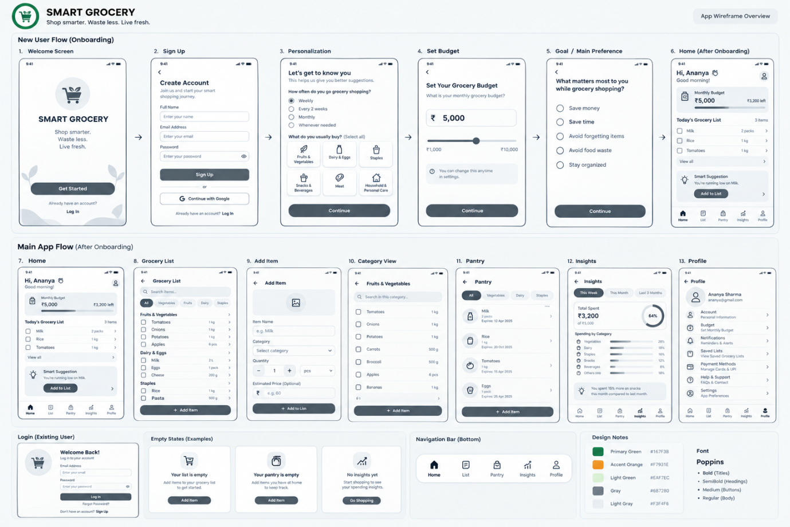

IMPLEMENT:
